Carrie Lynn Theiss
Organic Conceptions
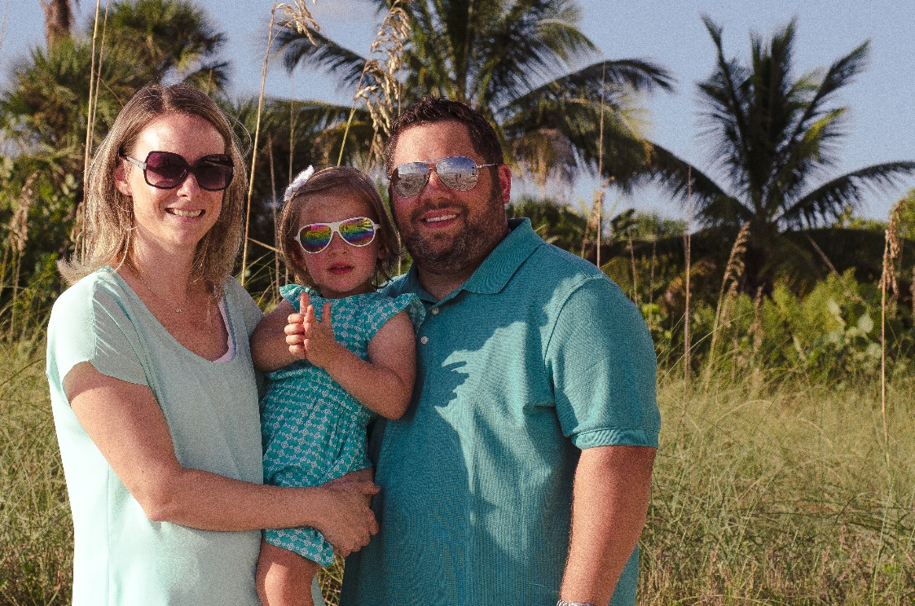

Short Description: After two failed in vitro cycles and to years of heartache, Carrie Lynn Theiss learned to relax and received the answer to her prayers just five months later: a beautiful baby girl. Who knows what the future may bring!
This is the story of my family. When I was little, I wanted to get married and have a baby…what most little girls dream of. I babysat every chance I got, spent lots of time with my younger cousins (even making my boyfriends at the time take them to movies and to the park with us), and at the time, even thought that I wanted to be a teacher as well. I loved kids and being around them.
So imagine my surprise when my husband and I officially started trying to have kids, and it just wasn’t working. We tried everything to get pregnant. We tried for years, did everything we were supposed to, including two IVF cycles that failed, acupuncture, herbs, you name it…we tried it. The hospital in Pittsburgh where I live is kind of a baby factory. They don’t always take an individualized approach unless you push personally. They don’t get that women know their bodies. You end up becoming a number.
It was hard, and trying, and pretty much awful. I cried, and stressed, and was depressed. I cried after seeing the infertility doctors; I cried the first time I gave myself the first shot (not from pain, but from relief that I could do it); I cried the mornings that I had a reaction to one of the meds and had to have Dan take me to Magee to make sure the reaction didn’t get worse. I cried a lot.
We decided to take a break from IVF after the second one failed. I pushed for some exploratory surgery to see if there were any issues with my body. I felt that there had to be some reason these babies weren’t implanting, even though earlier tests they did with me showed no issues, so I pushed them to take an extra look in my uterus while they were looking for endometriosis. Doctors found that I had a septum in my uterus, which divided it in two, making implantation more difficult. I decided we needed a break and more importantly my body needed a break. We can just try without trying for a while. At that point, I think if one more person told me “just relax” I would have smacked them, but I think there must have been something to it because I ended up pregnant 5 months later totally naturally.
In November 2012 I gave birth to a beautiful girl 5 weeks early. She was a healthy baby at 6lbs 3ozs. She was everything I had hoped and dreamed of for years. She was our little miracle.
And I knew motherhood was hard (as was the getting there), but it is also rewarding. Everyone tells you it’s hard, and everyone gives you advice. But as a mom you need to take everything you know and everything you have learned and follow your own path. Being a working mother is hard. Being a stay at mom is hard. It’s hard if you have help, it’s hard if you don’t. The nights are hard when she gets up at 1am, the mornings are scary when they sleep through the night for the first time because you panic something is wrong. But I wouldn’t change it for anything in this entire world. Nothing good is easy, right?
Which was why we decided to try again using the last embryo from the IVF treatments we did before we had our daughter. This time, I had to go through all the testing all over again, and even had some of the results come back differently, which required further testing. However, when it all came down to it, everything was okay, and we were given the green light to try to use our final frozen embryo.
Due to many factors we decided to wait until late January/early February to start the process. So I started daily meds in February and we began our journey. I continued doing testing and added more my meds throughout the month. Everything was going as planned. The embryo thawed successfully and started growing as it was supposed to. I had acupuncture before and after the transfer because we wanted to give this embryo every chance we could. I rested like I was supposed to for the next 48 hours and didn’t lift M for the next two weeks. I was the perfect patient.
Even though they advise against it, I will admit, starting in the middle of the second week I started taking pregnancy tests. They were all coming back negative, but I was still positive and looked forward to the next day hoping that the results would change. My monthly friend never showed up and even though the test kept coming back negative I hoped and prayed when I went in for my blood test that it would come back positive. I tried to remember that with my daughter my hCG levels were lower than they would normally be at first, but still had a pretty healthy pregnancy with her.
During this whole process I prayed to God, at times I felt frustrated with God, and even once or twice tried to bargain with him… sometimes all within the same day. I asked friends and family to pray, cross fingers, or talk to whoever they believe in.
But despite following everything to a T, despite all the well wishes, thoughts and prayers, it didn’t work. A lot of friends and family have asked what is our next step…Will we try again with the doctors…will we keep trying on our own…would we adopt…or will we just move on? I felt a loss with this one, more than the two failed IVFs before our daughter. It’s a lot of money, stress, and takes a toll on my physical and mental state. I will say I’m tired of “babysitting” my monthly schedule. We were so very blessed with one beautiful healthy sweet little girl, so who knows what’s meant to be. I was an only child and I turned out semi-okay right? (No comments from the peanut gallery!) So for now, I want to enjoy my family and let what may be, may be.
Again, I know we were blessed. We have one. It hurts my heart to know there are others out there with no children and that they want them badly but can’t have children, have had miscarriages, have gone through what we went through, or other similar situations. But I remain positive: if there’s anything this process has taught me, it’s that who knows what the future may bring.

